Rental prices
Sky | 500 DKK
Rainbow | 375 DKK
Cloud | 250 DK
Kitchen (can only be booked for Sky-booking) | 0 DKK

Renter
Responsible for booking | Name
 | E-mail:
 | Phone:
 | Floor and room number
 | Full CPR-number

Room booking
Room | Sky ☐ | Rainbow ☐ |  | Cloud ☐ |  |  | Kitchen ☐
Date and time
Purpose
Text for info-screen
Number of guest
Table setting  (see page 3 for more information) | Hestesko ☐ |  | Klasseværelse ☐ |  | Foredrag ☐
 | Mødebord ☐ |  | Lange borde ☐ |  | Hestesko (spisning) ☐
 | E bord ☐ |  | Reception ☐ |  | Lounge (kun Cloud) ☐
 | You will put up tables and chairs yourself ☐
Comment
Presentation equipment | Projektor ☐  Mac adapter ☐ |  | Whiteboard ☐ |  |  | Flipover ☐
Other equipment  (first-come, first-serve basis) | Table microphone ☐ |  | Rostrum ☐ |  |  | Cleaning wagon ☐

Price total (filled out by the Accommodation Office) | Kr.

The rental price for the room will be charged via your bill for rent, which is sent by Kollegieboligselskabet.

By signing this rental agreement, I declare myself personally responsible for understanding and following the rules and conditions for rental of rooms at Campus Kollegiet, as stated in this document, along with the Dormitory Orders for Campus Kollegiet.

The key-card must be returned no later than 05:00 the following morning. The key-card can be returned in the Accommodations Office’s mailbox on the ground floor.

Dato: |  | Lejer underskrift |  | SDU Bolig underskrift

Conditions for rental
If these conditions are violated, the janitor or Accommodation Office can cancel the booking without warning. If the violation concerns material damage, there will be economic consequences.

- Sunday to Thursday, the rooms can be rented in the time period 7 AM- 11 PM. Friday, Saturday and the day before a holiday, the rooms can be rented in the time period 7 AM – 3 AM. Access is granted by the Accommodation Office.
- Rental of the rooms is on a first-come/first-served basis. That means that if the rooms have already been booked by staff at SDU or an external party, it will not be possible for a tenant to book the rooms.
- Maximum number of people for each room:
- Sky: 70
- Rainbow: 56
- Cloud: 15
- The rooms can be used for meeting, reception, parties, workshops and the like. The rooms may not be used for sales (such as flea markets) or events booked on the behalf of someone else (such as parents’ anniversary). Family and friends are welcome to book the rooms at standard rental rate.
- The rooms should be left in the same conditions as they were found.
- Demands from authorities must be adhered to
- The renter must familiarize her- or himself with the instructions for fire and evacuation (see attached escape-plan).
- The total smoking ban on the premises must be adhered too – this also includes balconies and terraces.
- It is not allowed to sleep/spend the night in the rooms.
- Candles are not allowed, as they can develop enough smoke/heat to set off the fire alarms.
- The noise level must be kept at a tolerable level.
- Støjniveau skal holdes på et menneskeligt niveau. Tenants must be notified.
- Tenants on 13th floor must be notified, if the noise level is going to be above normal speaking-level.
- Fog-machines of any kind are prohibited. If you are to use any equipment that is not provided by the Accommodation Office, this must be approved by the janitor.
- Fireworks and the like are prohibited. This includes balconies, terraces and any other places in the premises.
- It is not allowed to throw anything (soft or hard) from the balconies and terraces.

Additionally, please refer to the Dormitory Orders.
Violation of these conditions may have severe consequences.

Conditions for cleaning and maintenance
- The renter is personally liable for cleaning of the room. The janitor at Campus Kollegiet will always order professional cleaning after the room has been rented. The amount will be charged via the renters rent. If the rooms are rented close to the renter’s moving-out date from Campus Kollegiet, the amount will be withdrawn from the deposit for the renter’s room at Campus Kollegiet. The rate for this will follow the SDU-rate:
  - Price during the day: 275 DKK per hour, ex. vat
  - Price during the night: 305 DKK, ex. vat
  - Price on Sundays and holidays: 610 DKK, ex vat
- The renter is personally liable for failure to maintain the rooms, i.e. damage or loss of items. I case of failure to maintain the rooms, the janitor at Campus Kollegiet will order the damages repaired or purchase new items, and the price of this will be charged via the renter’s rent. If the rooms are rented close to the renter’s moving-out date from Campus Kollegiet, the amount will be withdrawn from the deposit for the renter’s room at Campus Kollegiet.
- The above also applies to hallways, bathrooms elevators and kitchen.

What should I do after renting a room?
- The rooms should be emptied for bottles, cases, tableware etc.
- Tables, chairs and equipment should be placed in the standard-setting. See plan by the door.
- The lights should be turned off and the door closed.
- The room should be vacated at the agreed-upon time (see time at the top of the rental agreement).
- Potential damage to building, or damage or loss of furniture and equipment will be repaired at the renter’s expense.
- Posters and the like should be removed. Remember! Only interval announcement at the dormitory.
- Potential expenses for cleaning and assistance is paid by the renter.
- The above also applies to hallways, bathrooms elevators and kitchen.
If you have rented the kitchen, the conditions below also apply:
- It is the renter’s responsibility to wash and put away tableware.
- Surfaces and refrigerator must be wiped off.
If the above is not done, the janitor at Campus Kollegiet will order professional cleaning, and the amount will be charged via the renters rent. If the rooms are rented close to the renter’s moving-out date from Campus Kollegiet, the amount will be withdrawn from the deposit for the renter’s room at Campus Kollegiet

Other practical information

Rent
The rent covers:
- A table set-up in one of the possible set-ups on page 3.
- Normal wear and tear.
- Expenses for electricity, water and heating.

The rent does not cover:
- Exit cleaning. The renter is personally liable for cleaning of the room. The janitor at Campus Kollegiet will always order professional cleaning after the room has been rented. The rate for this will follow the SDU-rate, which per January 2017 is 350 DKK per hours including Vat. The amount will be charged via the renters rent. If the rooms are rented close to the renter’s moving-out date from Campus Kollegiet, the amount will be withdrawn from the deposit for the renter’s room at Campus Kollegiet.
- Assistance from SDU staff, unless it is agreed-upon in writing.
- Potential damage to building, item, furniture and equioment.

Kitchen
- There is tableware for 70 people in the kitchen, which can be rented when you rent Sky.
  - There is coffee machine and filters, but coffe, milk og succer must be provided by the renter.
  - There is not serving dishes, bowls or serving-cutlery.

Ordering food
Until February 28, 2022. Food can be ordered at Cozy Café on the ground floor. Please contact the owner, Pernille from at pernillefrom@hotmail.com - 44 11 68 08. From March 1st, 2022, the café will be closed. You can order food from whichever place you like.

Cancellation policy
You can cancel the room free of charge up until ont moth before the booking.
If cancellation happens after this time, you will be charged a fee. If the cancellation happens 30-14 days before, the fee is 50 % of the rental price. After this time, the fee will be 75 % of the rental price.
Information on parking
There is free parking withing registreration requirements on weekdays after 14:30 and during the weekend. If your event is on a weekday between 8:00-14:30, your guest must register their car at the Accommodation Office.

To get access to the room, you must get your key-card at the Accommodation Office on the day you have rented the room before 2.30 pm. If you have booked the room during the weekend, you must pick up the key-card before 2-30 om on the Friday before your booking. We are located on the grounf floor of Campus Kollegiet.
Any potential questions or disputes will be handled by Techinal Services. Contact the Accommodation Office at bolig@sdu.dk or phone 6550 2053.

With my signature, I declare myself in agreement with and responsible for the mentioned conditions and the Dormitory Orders.

Table set-up
 | Sky | Rainbow | Cloud
Hestesko | 34 personer | 26 personer | 16 personer
Klasseværelse | 50 personer | 24 personer | 12 personer
Foredrag (kun stole) | 70 personer | 56 personer | 21 personer
Mødebord – Uden projektor | 24 personer | 26 personer | 14 personer
Mødebord – Med projektor | 22 personer | 24 personer | 10 personer
Lange borde | 70 personer | 42 personer | Ikke muligt
Hestesko (spisning) | 46 personer | 26 personer | Ikke muligt
E bord | 70 personer | Ikke muligt | Ikke muligt
Reception | 90 personer | 60 personer | Ikke muligt
Lounge set up | Ikke muligt | Ikke muligt | 13 personer

Table set-up (examples)
Hestesko | Klasseværelse | Foredrag
Mødebord uden projektor | Mødebord med projektor | Lange borde
Hestesko (spisning) | E bord | Reception (max 16 caféborde)
 |  | 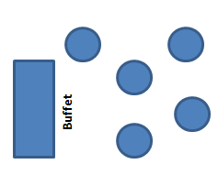

Escape plan 13. floor
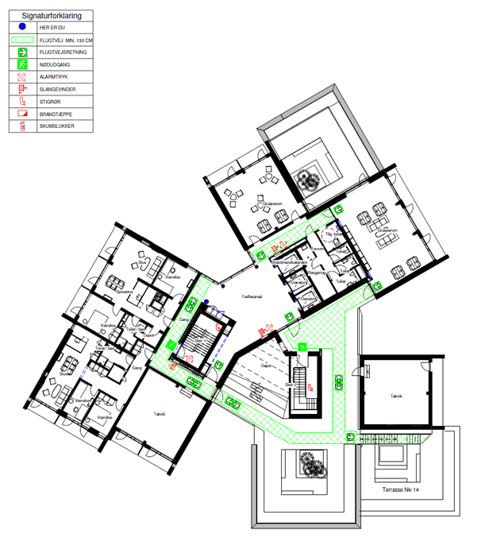

Escape plan 14. floor
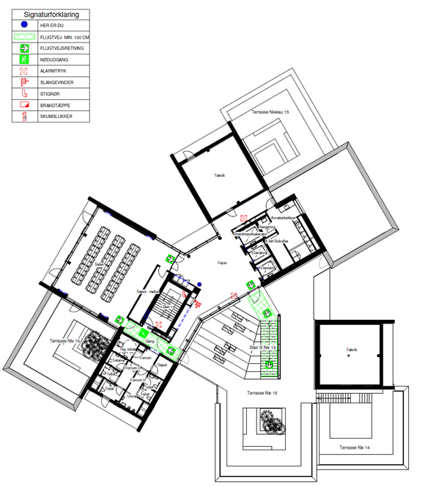

Pictures of the rooms
Sky
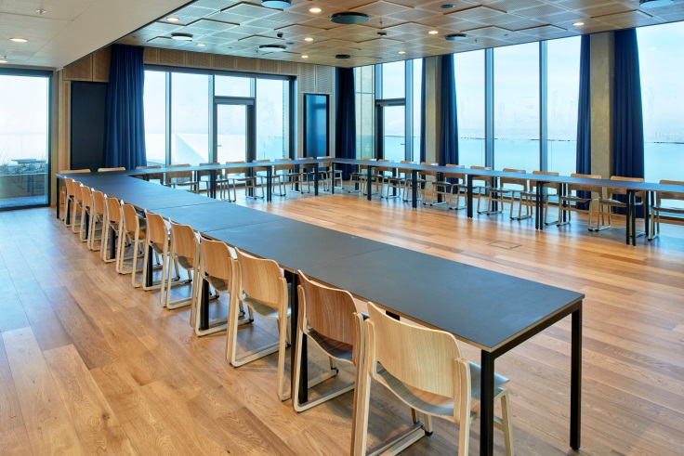 | 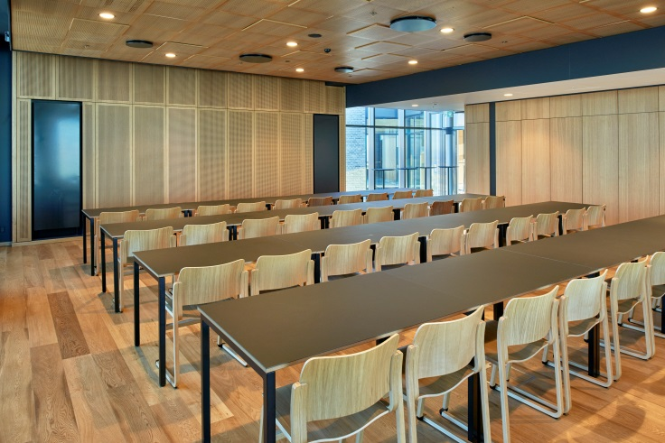
Rainbow
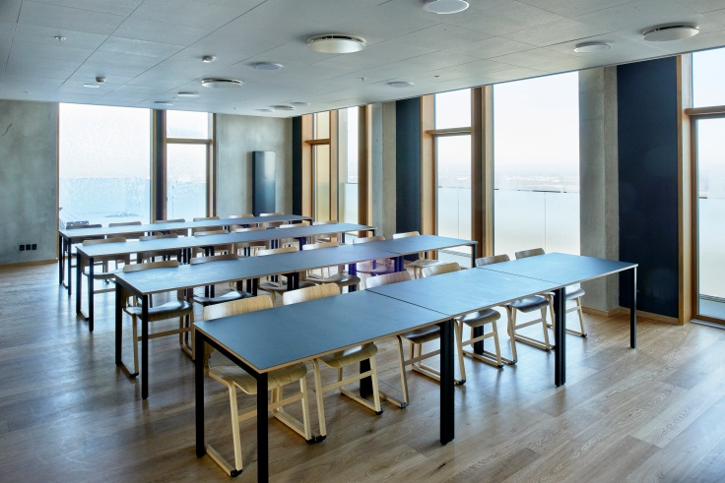 | 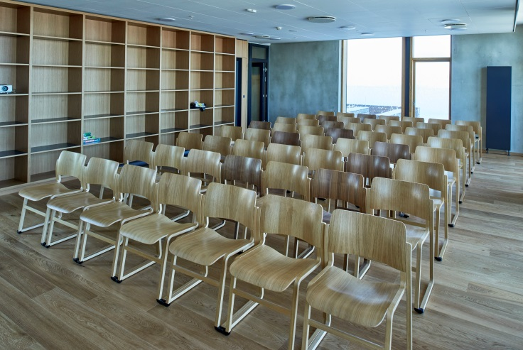
Cloud
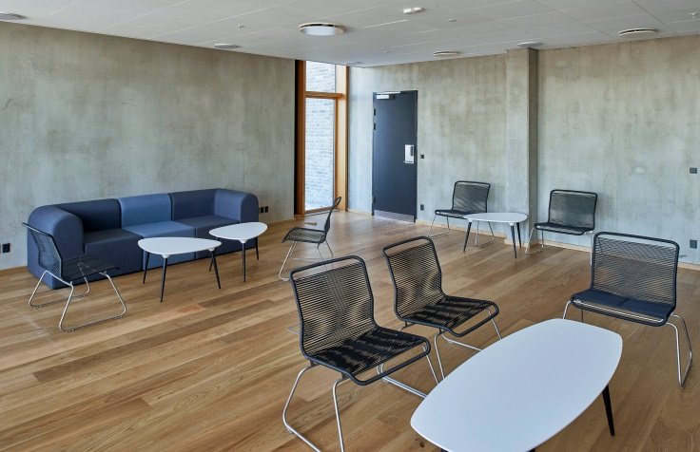 | 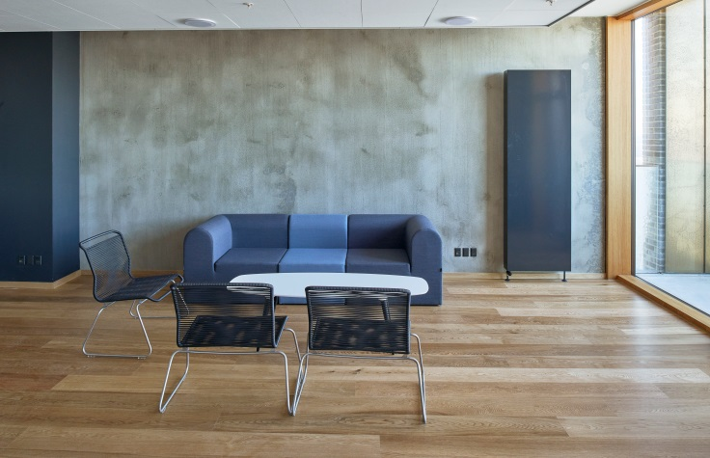
Anretterkøkken
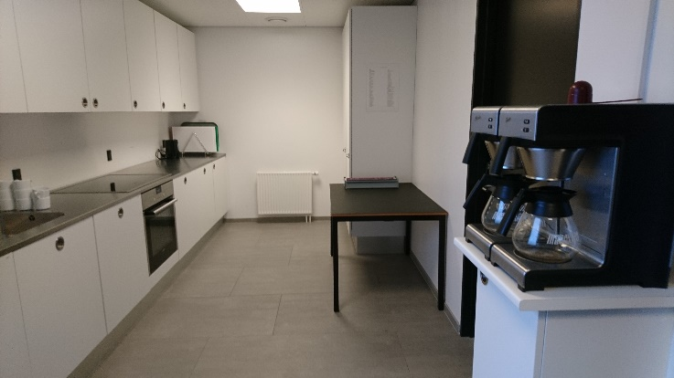 | 